**What is Linux?**

Linux is a free and open-source family of operating systems that is resilient and flexible.

**Linux Operating system:**

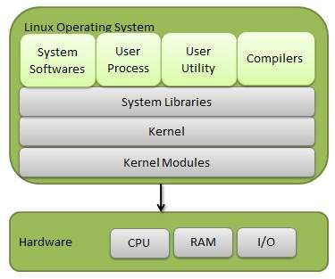

Linux operating system is a powerful and flexible open-source software platform for multitasking and multiusers operations.

**System Library**: Linux uses system libraries, also known as shared libraries, to implement various functionalities of the operating system.

**Shell:**The shell is the user interface between the user and the kernel.

Kernel: The core components of the os that manage hardware resources and system operations.

**Hardware Layer:**The hardware layer encompasses all the physical components of the computer, such as [RAM (Random Access Memory),](https://www.geeksforgeeks.org/random-access-memory-ram/) [HDD (Hard Disk Drive),](https://www.geeksforgeeks.org/difference-between-hard-disk-drive-hdd-and-solid-state-drive-ssd/)CPU (Central Processing Unit), and input/output devices.

**System Utility:**Tools that perform specific task for system management and maintenance such files management and performance monitoring.